IN SITU – CE1494
IN SITU – Veneto Social Innovation Hub
Activity A.T3.1

BUSINESS PLAN SEMPLIFICATO *

Denominazione del progetto imprenditoriale

Nome e cognome del Referente

* Basato sul Business Model Canvas ®

- Value Propositions
What value do we deliver to the customer?
Which one of our customer’s problems are we helping to solve?
What bundles of products and services are we offering to each Customer Segment?
Which customer needs are we satisfying?
CHARACTERISTICS [Newness / Performance / Customization / “Getting the Job Done”/ Design / Brand/Status / Price / Cost Reduction / Risk Reduction / Accessibility / Convenience/Usability]

- Customer Segments
For whom are we creating value?
Who are our most important customers?
Mass Market / Niche Market / Segmented / Diversified / Multi-sided Platform

- Customer Relationships
What type of relationship does each of our Customer
Segments expect us to establish and maintain with them?
Which ones have we established?
How are they integrated with the rest of our business model?
How costly are they?
EXAMPLES [Personal assistance / Dedicated Personal Assistance / Self-Service / Automated Services / Communities / Co-creation]

- Key Partners
Who are our Key Partners?
Who are our key suppliers?
Which Key Resources are we acquiring from partners?
Which Key Activities do partners perform?
Optimization and economy / Reduction of risk and uncertainty / Acquisition of particular resources and activities

- Key Activities
What Key Activities do our Value Propositions require?
Our Distribution Channels?
Customer Relationships?
Revenue streams?
Production / Problem Solving / Platform/Network

- Key Resources
What Key Resources do our Value Propositions require?
Our Distribution Channels? Customer Relationships?
Revenue Streams?
TYPES OF RESOURCES [Physical / Intellectual (brand patents, copyrights, data) / Human / Financial]

- Channels
Through which Channels do our Customer Segments want to be reached?
How are we reaching them now?
How are our Channels integrated?
Which ones work best?
Which ones are most cost-efficient?
How are we integrating them with customer routines?
CHANNEL PHASES: 1. Awareness - How do we raise awareness about our company’s products and services? / 2. Evaluation - How do we help customers evaluate our organization’s Value Proposition? / 3. Purchase - How do we allow customers to purchase specific products and services? / 4. Delivery - How do we deliver a Value Proposition to customers? / 5. After sales - How do we provide post-purchase customer support?

- Cost Structure
What are the most important costs inherent in our business model?
Which Key Resources are most expensive?
Which Key Activities are most expensive?
IS YOUR BUSINESS MORE: Cost Driven (leanest cost structure, low price value proposition, maximum automation, extensive outsourcing) / Value Driven (focused on value creation, premium value proposition)
SAMPLE CHARACTERISTICS: Fixed Costs (salaries, rents, utilities) / Variable costs / Economies of scale / Economies of scope

- Revenue Streams
For what value are our customers really willing to pay?
For what do they currently pay?
How are they currently paying?
How would they prefer to pay?
How much does each Revenue Stream contribute to overall revenues?
TYPES: Asset sale / Usage fee / Subscription Fees / Lending/Renting/Leasing / Licensing / Brokerage fees / Advertising
FIXED PRICING: List Price / Product feature dependent / Customer segment dependent / Volume dependent
DYNAMIC PRICING: Negotiation (bargaining) / Yield Management / Real-time-Market

Analytical Economic & Financial previsions

EF.1 – COST STRUCTURE

EF.2 – REVENUE STREAMS

EF.3 – PROFITS & LOSSES

EF.4 – SYNTHETIC CASH FLOW

The company’s poster

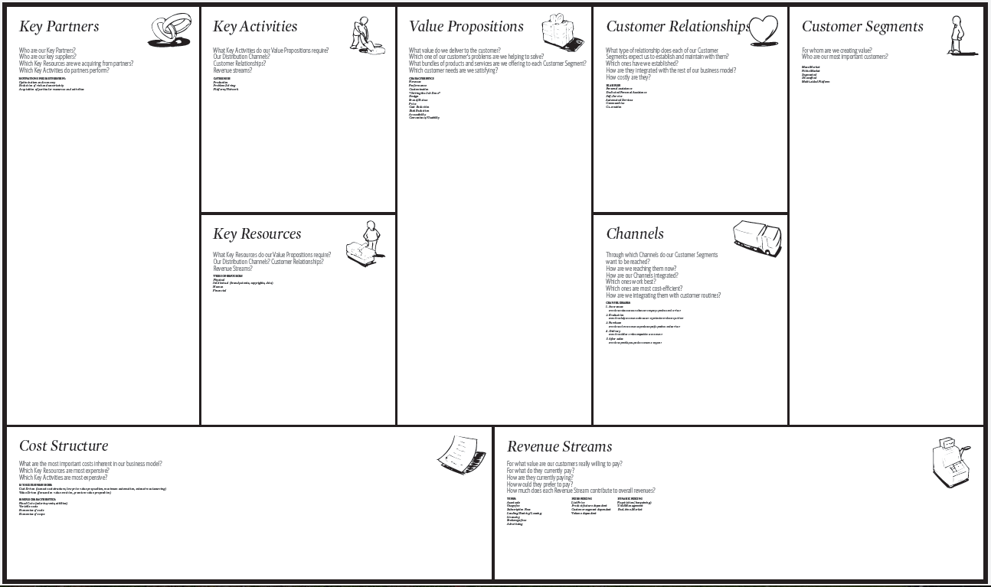

This work is licensed under the Creative Commons Attribution-Share Alike 3.0 Unported License.

